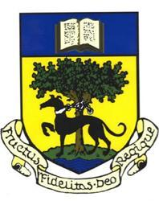

LINLITHGOW ACADEMY PARENT COUNCIL

Linlithgow Academy Parent Council Meeting
Wednesday 26th November 2025
7.00 pm – 8.30 pm
Meeting in school and Zoom video conference

AGENDA

1. Welcome and apologies
2. Minutes of the previous meeting and matters arising
3. Items from Parent Forum
Discussion items submitted by parents/carers in advance of meeting
4. Focus Topic: Learning Support / Specialist Resources
5. Treasurers report
6. Fundraising update
7. Head Teacher update
8. Any Other Business (AOB)

