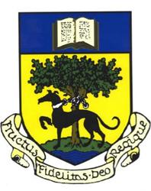

**LINLITHGOW ACADEMY PARENT COUNCIL**

Linlithgow Academy Parent Council Meeting

Wed 4th June 2025

7.00 pm – 8.30 pm

Meeting in school and Zoom video conference

**AGENDA**

7.00 Welcome and apologies

7.05 Minutes of the previous meeting and matters arising

7.10 Items from parent forum

7.20 PC year review

7.30 Focus Topic: School Improvement Plan

7.55 Treasurers report

8.00 Fundraising update

8.10 Head teacher update

8.25 AOB

Dates and proposed focus topics for Parent Council Meetings for 2024/25

* + PC meeting 1 Mon 02/10/24 Senior Phase Curriculum Rationale
  + PC meeting 2 Tue 19/11/24 IT and digital training
  + PC meeting 3 Wed 15/1/25 Support for pupils including health issues and neurodiversity
  + PC meeting 4 Tue 4/3/25 Supporting parents to assist home learning
  + PC meeting 5 Thur 1/5/25 Parent/ & carer/community engagement
  + PC meeting 6 Wed 4/6/25 School Improvement Plan

