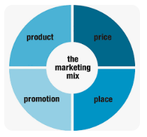**S2 The Marketing Mix**

Using a business of your choice explore with your family members how they have created & developed their marketing mix.

|  |  |
| --- | --- |
| Products | Prices |
|  |  |
| Places | Promotions |
|  |  |