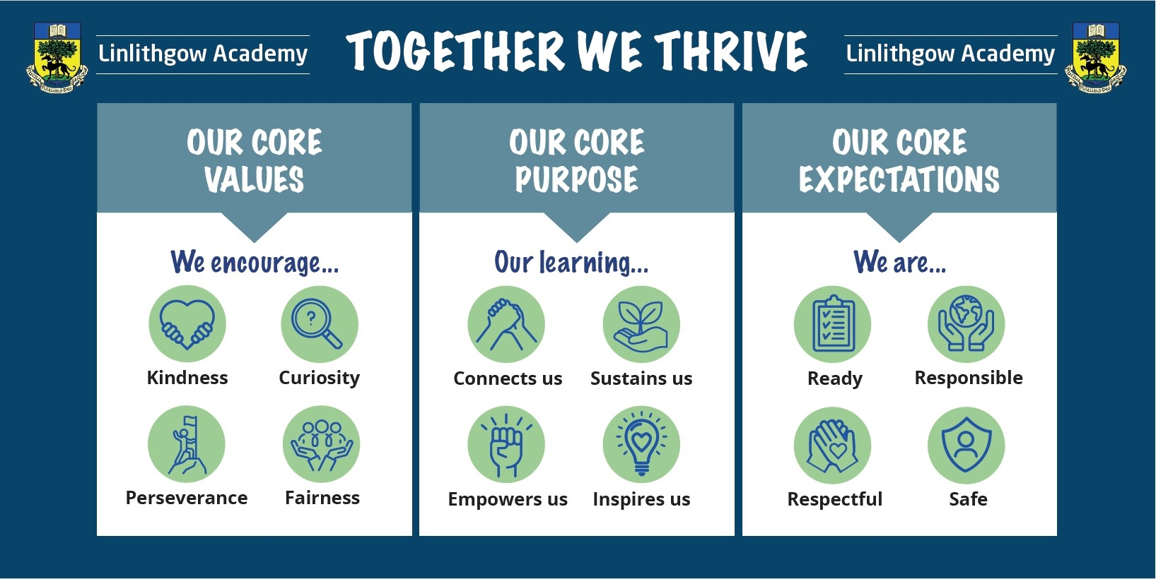  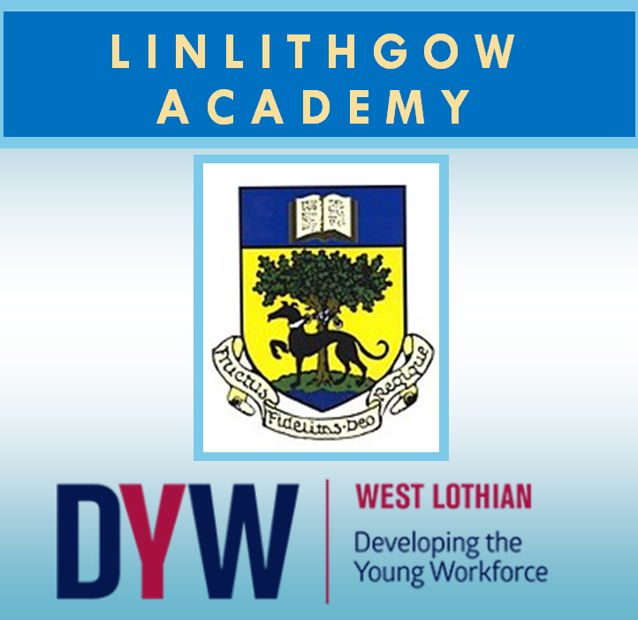  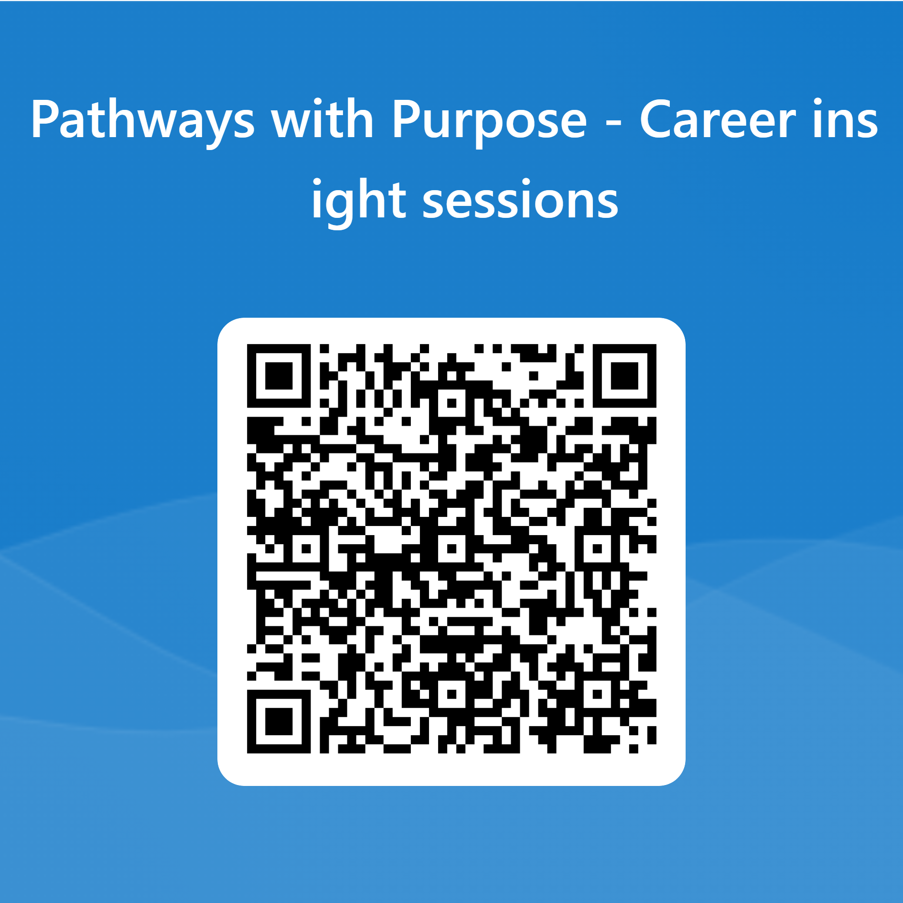  - StaRting soon!  Pathways with Purpose  Open to all S3 to S6 Pupils  Have you started thinking about your career yet? Are you uninspired? Confused? Our Pathways with Purpose sessions aim to give pupils relevant and entertaining insight in a variety of careers and pathways open to you. We have invited experts and employers from local, National and International companies to deliver sessions aimed at showing pupils the exciting and varied opportunities that await you in the big wide world!  These sessions aim to -  - To empower you people to make informed choices about their career paths​  - To connect you to experts across many industry areas and connect their learning to future pathways​  - To inspire you to explore various industries, opportunities and pathways you may be unfamiliar with​  Interested? Click the form to sign up! Or use the QR code below  Sessions are limited to about 30 pupils and will be on a first come/ first served basis.  Wednesday sessions will be held between 2 - 3.30pm in B13  Friday session will run between 10.45- 12.15pm in B13 | Speakers Sept - Dec  More likely to be added!  Friday 29th Sept - Scottish Fire and Rescue  Wed 4th Oct - Finance and Business  Friday 20th Oct - Historic Environment Scotland  Friday 27th Oct - Public Sector/ Life Sciences  Wed 1st Nov - BBC- political correspondents/ presenters  Wed 8th Nov- Photography  Friday 10th Nov – Bottlegreen websites  Wed 15th Nov - Zenergi - Sustainable energy  Friday 24th Nov - Software development  Friday 1st Dec - Speech and Language therapy  LINK TO SIGN UP

