**S1 PSE – Family Learning**

**Term 1 – Planning for Choices & Changes**

This term, we will have a visit to our PSE classes from Paul Mathers, our Careers Advisor.

The Family Learning activity related to this is to familiarise yourselves with the Skills Development Scotland (SDS) careers website, My World of Work.

* Register on My World of Work [**www.myworldofwork.co.uk**](http://www.myworldofwork.co.uk)
* Have a look around the website and complete the ‘About Me’ and ‘Strengths Tool’ sections

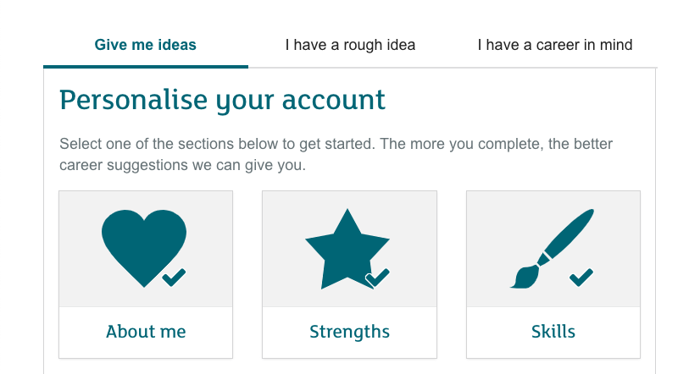

* Use the resulting list of career suggestions to pick out a few of interest, find out what you can about them and discuss what it is that is of interest.