|  |  |
| --- | --- |
| Making the most of your revision | History Department  Linlithgow Academy |

This booklet has been designed to give you some practical ideas for revising for your History exam. It does not cover any content (though some will be used in examples). You may even find it helpful for your other subjects!

Revision is most effective when you are USING information. The ideas below all require you to think about content and use it in a new way. Repetition of this process will help you retain facts.

**Learning Styles**

Different people learn in different ways. Decide which style you prefer and use the following techniques. If you don’t know which you are, try each and see which style works best for you.

VISUAL

* Use pattern notes/mindmaps/ posters/ leaflets/ Dvds/ YouTube/ Pictures/ Diagrams
* Visualisation of information and outcomes
* Highlighting
* Transform information into cartoons
* Subject specific vocabulary / key words on cards
* Computer – revision sites like bitesize
* Use key words – display key words and key information around your room just above eye level
* Attach pictures or images to keywords/information to improve memory

AUDITORY

* Any activities involving reading AND listening or speaking
* Describe out loud what you are doing as you do it
* Describe something either in writing or orally, in your own words
* Make rhymes, jingles, songs etc.
* Discuss your plans/ideas/answers with a partner
* Report back / present / teach someone else what you have learnt
* Use podcasts, record yourself speaking and listen to them whilst on bus etc.
* Put key words to a familiar or popular tune – e.g. Happy Birthday, favourite song
* Create your own questions and use these for quizzes, bingo, nought and crosses and board games.

PRACTICAL

* Use role play, re-create or re-enact an event,
* Use models – create a model of the human heart, plan a battle etc.
* Use paper based activities – write notes/key words on post its, post cards or scrap paper then use to arrange, organise, plan, sequence, classify and prioritise or turn into pattern notes/mind maps
* Use movement – walk, dance, run while listening, reading, talking out aloud
* Games: bingo, noughts and crosses, pairs

**Practical examples**

1. **Past Papers**

You can use past papers in a number of ways

* Do the questions, then ask your class teacher to mark them
* Use the marking schemes to make up perfect ‘model answers’
* Take notes from marking schemes on the different bits of knowledge or historiography you could use in various topics

A link to the SQA past paper site is below –

<https://www.sqa.org.uk/pastpapers/findpastpaper.htm>

Most decent bookshops will also stock past papers books too.

1. **Circles of Significance (very helpful for essays/ 9 mark responses)**

The idea here is to organise your factors by importance. Write your most important factor and associated notes in the biggest circle and continue until your least important factor and notes are in your smallest circle. A template is below.

At National 5 level this will help you plan responses to 9 mark ‘To what extent’ questions and frame your Assignment paragraphs.

At Higher level this is a very helpful tool when weighing up your factors in essay planning, particularly if you are looking for ‘Evaluation’ marks.

Most important/ significant

Least important/significant

1. **Gold Silver Bronze**

Useful as a quick revision tool on a **narrow** topic. Eg. How did the Slave Trade impact Bristol?

Think of the 3 most important facts to do with that issue. Write them down – your most important fact is your GOLD fact, then Silver then Bronze – example below

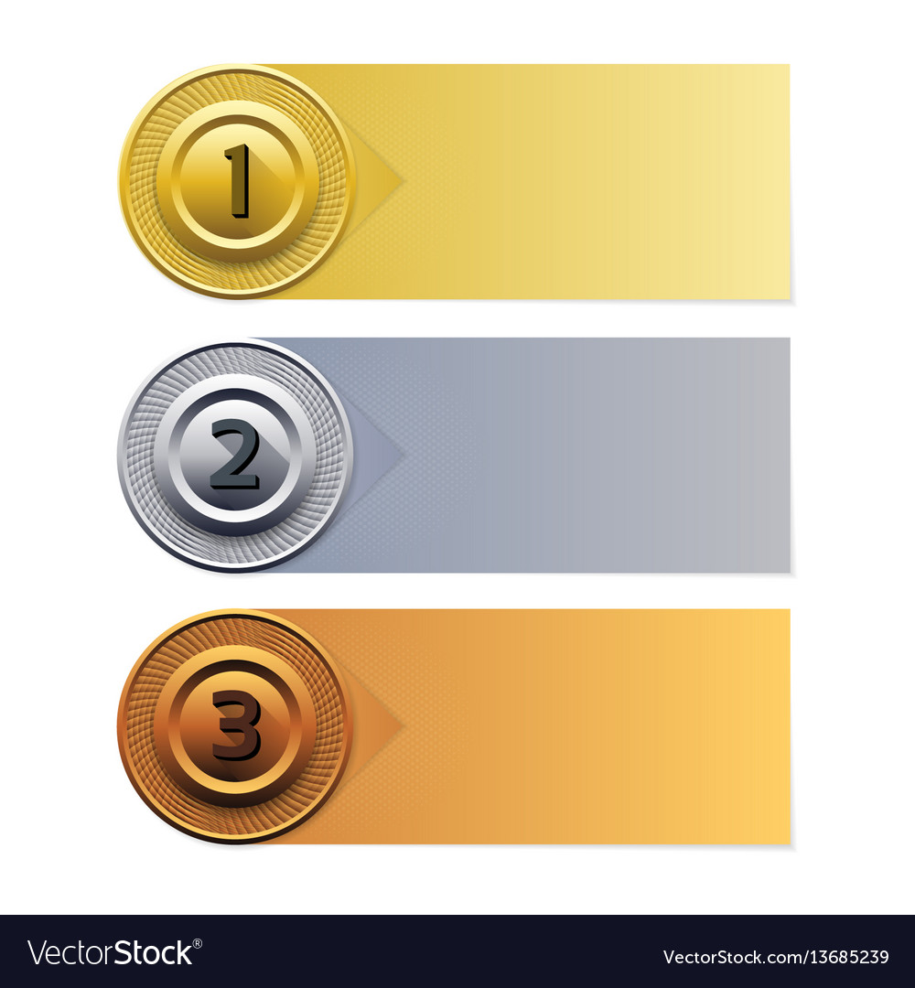

Bristol had been trading enslaved Africans long before the height of the Atlantic Slave Trade – this had made Bristol entrepreneurs wealthy

Money earned from the Slave trade was invested in to fine buildings and industries in Bristol

Bristol’s position on the West Coast of England gave it an advantage over London so it became a very busy port

1. **Fact Catcher**

A useful tool for when you are revising questions that require several points of recall. All of Paper two at Higher for example of explain and ‘To what Extent’ questions at National 5.

Use the course specifications on the SQA website to identify subheadings (this is the column on the right) for each topic. For each subheading, you need to be able to recall at least 8 facts. An example layout is given below for section 1 of Mary Queen of Scots at N5. Just change it up for whatever section you are looking at!

|  |  |  |  |
| --- | --- | --- | --- |
| Scottish society and Church in the 1540s: landowners, burghs, clergy; power of the monarchy and nobility at the death of James V. | The Church’s faith, organisation, failure of attempts at reform. | Relationship with England and France: the ‘rough wooing’; Mary’s move to France. | Her dynastic position on the accession of Elizabeth I. |
| Fact 1 |  |  |  |
| Fact 2 |  |  |  |
| Fact 3 |  |  |  |
| Fact 4 |  |  |  |
| Fact 5 |  |  |  |
| Fact 6 |  |  |  |
| Fact 7 |  |  |  |
| Fact 8 |  |  |  |

1. **If this is the answer what is the question?**

A nice activity to do with a study buddy!

Create a list of key words/ people/ facts/ phrases. Challenge a partner to make up a question that can only be answered by the word of phrase on the list. For example if the answer is ‘Eight to ten weeks’ the questions could be ‘How long did the Middle Passage take on average?

Again, you may find it useful to look at the course specification here and organise your answer lists by sub topic

1. **The good old mind map!**

* You only need to write down what’s important
* You can easily show how things link up
* All the information you need is on one page
* When you have made a pattern, your brain will remember the whole shape of the topic.

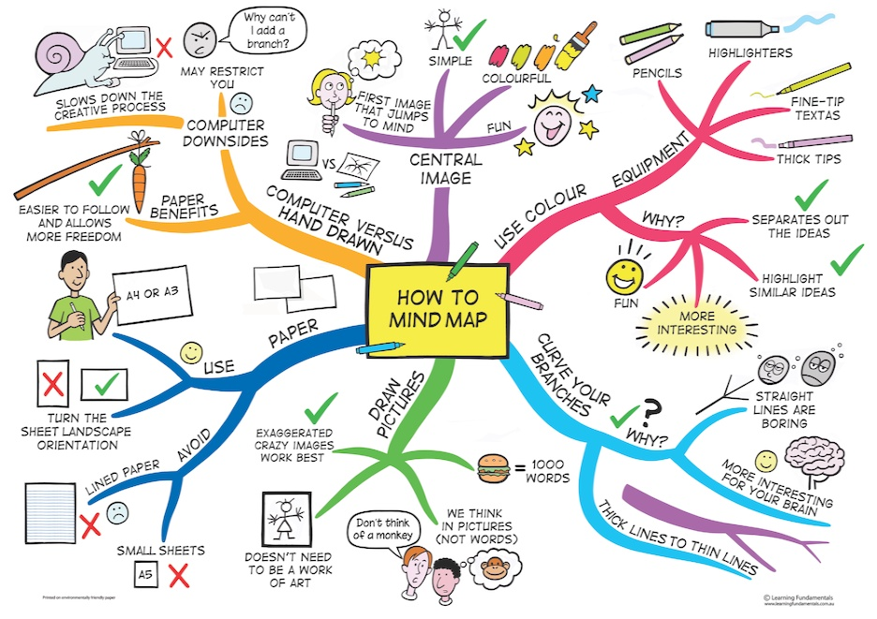

1. **Nightmare before your exam!**

Useful for targeting more tricky concepts

Create an exam paper OR set of questions that you would hate to be in the exam, in order target your revision. Once you have identified the killer topics you can either write answers to the questions or make up your own marking scheme.



1. **Zone of relevance**

This is where you have an exam question and use notes to select the most relevant information for that specific question.

This activity can help to understand, the most important and relevant information that specifically answers the exam question. Another useful technique for 9 mark or essay planning. Can be helpful in organising your analytical points. May also be useful when revising explain questions.



1. **Revision clock**

Really helpful for N5 where you need a lot of KU. You may wish to break down each section in to 12 key areas

At Higher you could make up a clock for each of the 4 topics in the Scottish paper

Instructions -

* Break down topics into 12 sub-topics.
* In each segment you can make or illustrate diagrams and summarise key information.
* Each segment has a 5 minute time limit, in order to break down learning into smaller pieces.

 



1. **BUGS!**

Grab an A3/4 bit of paper and write an exam question in the middle of it

**Box** the instructions so you fully understand what they need to do; this could be explain, evaluate or describe…etc.

Then they **Underline** key ideas/ focus of the question, again ensuring full understanding of what content will be needed in their answers.

Then **Glance** over the question once more to make sure you don’t rush to answer the question and possibly miss out any important information or read the question wrong, which can happen especially, under exam pressure.

**Summarise** the main content needed for that question around the paper.

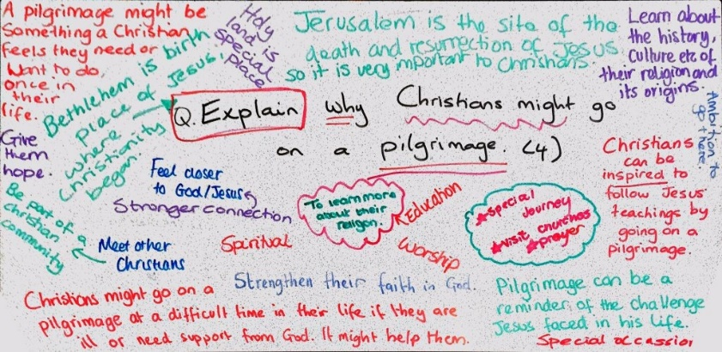

Example

1. **Flashcards (make them effective)**

Using flashcards to self-test helps you learn information, and helps you to identify any weak spots you may have with the material.

These are a great tool to use with a study buddy too!

* Use your notes or your textbook to identify key concepts in the material. On one side of a flashcard, write the name of the concept. On the back of the flashcard, write the definition.
* Make a stack of instruction flashcards that invite you to interact with and elaborate on these concepts. Use a different colour flashcard or different colour pen to keep these separate from your concept flashcards. Here’s a list of possible instructions to get you started, but each subject and topic will require slight tweaking of these instructions.
  + Describe a movie/television scene that depicts this concept
  + Describe this concept without using any key words written on the flashcard
  + Draw this concept
  + How would you explain this to a child/someone who has never heard of it before?
  + Mime this concept
  + Thirty seconds to give four knowledge points related to this concept
* Once you have two stacks of flashcards, you are ready to study! Shuffle both stacks, but keep them separate (colour coordination of the flashcards is helpful). Select one card from each stack and follow the instructions in regards to the concept that you selected. It is important to write or say aloud your responses to ensure that you can formulate and execute an answer.

1. **Let’s Play a Game!**

Useful for anything and great if there are few people wanting to study the same topics.

You are actively processing the information by making the game so you are more likely to remember it. By playing several times, you are repeating the revision. It is auditory and fun. If you include pictures/symbols/colours/different fonts on the game cards it will also be visual: 3 out of 4 factors which our memories like to work with.

Make games of your learning, such as:

* Key words snap: write as many key words from the topic as you like onto cards, one word per card. Play snap, against yourself or a partner. Every time there is a link between two of the key words, shout ‘snap’, explain the connection, if your partner accepts it you have won the cards. If you were revising GCSE History for example, and the words were ‘communism’ and ‘Czechoslovakia’ you might ‘snap’ these by saying that Britain was so afraid of communism that she excluded Russia from the meeting with Hitler about the future of Czechoslovakia in 1938.
* Index card time trial: write a term on one side and the definition/key information on the other. You have to accurately identify the information on the reverse within a set time. Play against a partner; you decide on the time limit and how many cards you have to accurately describe in that time. For example, you could have 3 cards in 30 seconds to score a point. You could also do this with questions and answers, rather than terms and definitions.
* Memory game: write each stage of a sequence on a different card. Turn them over. Turn over one at random and you have to say what comes before and what comes after. You could set yourself a time limit too and play against a partner.

1. **Have a Doodle**

Useful for revising whole topics – e.g different sections in N5 or whole essay topics at Higher. This strategy is also particularly helpful for the Scottish paper at Higher as it lends itself to storytelling and imagery.

This does take time to do – you will need to be thorough for it to be effective but once you have it done it is a great speedy way to remind yourself of key concepts and as a memory jogger.

What to do:

* Collect together all your notes on one topic (this example here is a N5 topic: recruitment for World War I)
* Now create a picture which links all of this information together.
* Make sure all of the bits of your picture fit together.
* Ideally, use colour, different font shapes and sizes to increase the visually memorable elements.

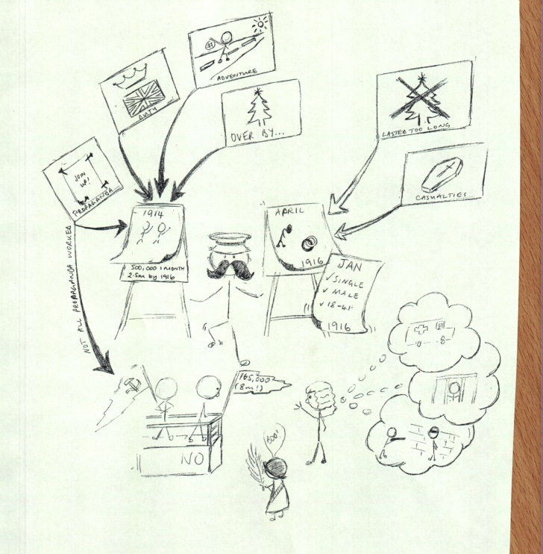

1. **Lotus Diagrams**

Very helpful for key subtopics as they can be divided up into subheadings.

At Higher, you could use the Lotus as an essay plan by placing your essay title in the middle and using each ‘bloom’ as a paragraph plan (you may not need all 8!). each fact could be accompanied by a bit of analysis/ analysis +

At N5 it will be helpful for Knowledge retrieval of topic sub headings. For example, you could place a topic heading like ‘The Triangular Trade’ in the middle and have the sub categories form the course specification as each lotus bloom.

A basic template is below

