**LINLITHGOW ACADEMY**

**ENGLISH DEPAR** **TMENT**

Within the English Department at Linlithgow Academy we aim to develop core literacy skills in order to ensure that learners experience a breadth of experiences and progress in their learning. The key skills that underpin the English curriculum build from early years (nursery onwards) and develop throughout the Broad General Education (BGE) and into the Senior Phase.

Courses have been designed to allow for progression across the BGE and into the Senior Phase, building on prior knowledge and skills.

Each lesson aims to ensure that learners are engaged in a curriculum that is tailored to their needs and ensures that appropriate support or challenge is provided for all pupils.

**Learner Pathways**

In English, all of our S1 pupils attend in their Register class groupings and therefore classes are mixed ability. We continue to have mixed ability throughout the BGE (S1-3) as we firmly believe this ensures that all pupils are able to get the best out of English. In S2 and S3 we do make some changes to class to allow pupils to work with a broader range of pupils in their year group etc however this remains mixed ability.

In the senior phase (S4-6) English remains compulsory for all learners in S4 – we aim to provide all of our learners with National 5 level experiences in order to provide the best opportunity for attainment to all – some learners will also work on National 4 outcomes alongside this in order to ensure qualification. In S5 and S6 pupils can choose to study Higher English or to study National 5 English if this was not previously attained. In S6 Advanced Higher English is also an opportunity available to pupils.

**Support**

Pupils will be supported in their learning through a variety of methods – this may be teacher support, differentiated learning materials, ICT or from a pupil support worker – if you have any questions about the support your child is receiving please do not hesitate to contact us.

**Skills**

Across the BGE and into the Senior Phase we teach a skills based curriculum focusing on the skills of: Reading, Writing, Talking and Listening.

In S1 we cover all of these skills and deliver outcomes that enable pupils to achieve at whatever level is appropriate for them. Each lesson cuts across BGE levels 2 to 4 as our outcomes are largely based on the same benchmarks but a differing degree of independence/challenge – this enables us to ensure that all learners are catered for in every English class.

**Reading:** In reading we ensure pupils access a wide variety of text genres (poetry, prose, drama and media) and begin to work on their analysis skills to allow them to better understand the language and structure of these. We start to develop critical essay writing skills which we continue to focus on as pupils move on through the school. In addition to this we work on Reading for Understanding, Analysis and Evaluation (RUAE) through investigating non-fiction texts and responding to a variety of tasks on these.

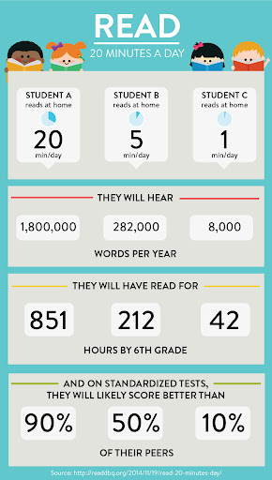**Reading for pleasure:** In S1 all pupils have a weekly reading period aimed at encouraging them to read for enjoyment – one of the key aspects of the literacy outcomes. Research shows that reading for pleasure has numerous benefits to our young people and we are keen to encourage this. As such, all S1 pupils should be aware when their literacy period is and we encourage pupils to come equipped with a book to read during this time – we do have a small selection available for pupils to choose from if they do not have their own.

**Writing:** Across the BGE pupils develop their writing skills in a variety of genres including creative (poetry, short story, drama scripts) and transactional (persuasive, discursive, informative and report). We work on developing sentence structure, language and spelling to create strong pieces of writing.

**Talking and Listening:** This forms an integral part of our BGE course – we ensure that there are many informal opportunities to develop talking and listening skills through class discussion and group work as well as more formal solo and group presentations. Pupils learn to develop their presentation skills and build their confidence in this area.

**Homework:** Pupils across the BGE will be issued with fortnightly ‘Commonlit’ homework tasks – these can be completed online and focus on reading comprehension. If a pupil forgets their log in/password please ask them to contact their class teacher to have this reset. On the other weeks we would encourage all of our pupils to be reading as much as they can – ideally at least 20 minutes per day!

**Contact us:**If you have any queries regarding your child’s English learning or progress please contact the Head of Department – Sarah Carney. You can email at [sarah.carney@westlothian.org.uk](mailto:sarah.carney@westlothian.org.uk) or phone the school on 01506 280180.