The Mathematics Department at Linlithgow Academy aim to build a curriculum developing a culture where learners take responsibility for their own learning and are engaged across the Broad General Education (BGE) and into the Senior Phase.

Courses have been designed to allow for progression across the BGE and into the Senior Phase, building on prior knowledge and skills, and continues to consolidate and remediate problem areas.

Through careful course design across the BGE and the implementation of teaching strategies based around the use of manipulatives and alternative representations, we aim to develop an understanding and fluency in number and algebra. This ensures that every learner will experience excellent learning by being included, engaged and are attaining.

Enrichment tasks are a feature of lessons, forming an integral part of learning. The Department are working hard to develop and foster a culture where all learners work hard and are responsible for their own revision and seek help with areas of difficulty.

**Learner Pathways**

On starting S1, classes in Mathematics attend in House Groups. This allows all learners a period to settle in, form relationships with their peers, and build confidence in their learning. Around the October Break, learners are reorganised into classes based on pace. The following provides an approximate timeline for S1 learners in Term 1.

When classes are reorganised by pace of learning, a range of assessment evidence is used to determine this, including:

* Scottish National Standardised Assessment data from Primary 7
* Professional judgement of Achievement of a Level from Primary 7
* CAT testing (conducted in Term 1)
* Direct observation in class
* Whole Number Assessment

By being set by pace, learners across the BGE work at a level which is appropriate to their needs and responsive to how they are coping with the curriculum. Pace is determined by how quickly a class can demonstrate understanding of each learned skill. Progression across the BGE usually conforms to the model of delivery below, which is consistent with guidance from Education Scotland as learners work across the five curriculum levels.

|  |  |  |  |  |
| --- | --- | --- | --- | --- |
| **BGE Progression at Linlithgow Academy** | | | | |
| **S1** |  | **S2** | |  | | --- | |  | | **S3** |
| Level 2 |  | Level 2/3 |  | Level 3 |
| Level 3 |  | Level 3/4 |  | Level 4 + |
|  |  |  |  |  |

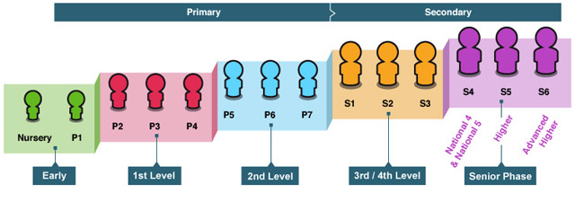

***Education Scotland – Curriculum Levels***

In S1, most learners focus on Level 3 but revisit prerequisite skills through consolidation of Level 2 and extend into Level 4 where appropriate. Most learners will then move onto Level 4 during S2 and continue to work on this in S3. Opportunities for progression to the next level are, therefore, not closed off.

**Developing Understanding and Mathematical Fluency**

Learners in Mathematics should find they are suitably challenged. Where a skill has been mastered, rich tasks afford the opportunity to further develop a conceptual understanding. Emphasis is placed on depth of learning. It is important that learners seek out these tasks and challenge themselves.

It is important learners have a clear understanding of the skill being learned before extending onto formal procedures. To develop understanding, various teaching approaches are utilised, including the use of concrete resources leading to pictorial representations, before extending on to the abstract algorithms. This is important for all learners but especially important for those lacking confidence in Mathematics. Some of these approaches include:

* **Bar Models** 🡪 pictorial representation which can help with topics like division, fractions, ratio, proportion, solving equations etc.
* **Dienes Blocks** 🡪 used to build number sense including addition, subtraction, place value etc.
* **Algebra Tiles** 🡪 initially helps to build understanding of positive and negative numbers, and then extends onto various algebra skills
* **Cuisenaire Rods** 🡪 helps to build understanding with the four operations and can extend onto fractions

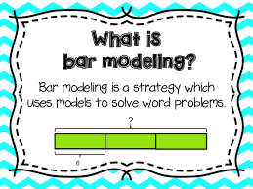 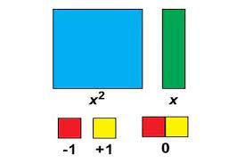

**Algebra Tiles**

**Dienes Blocks**

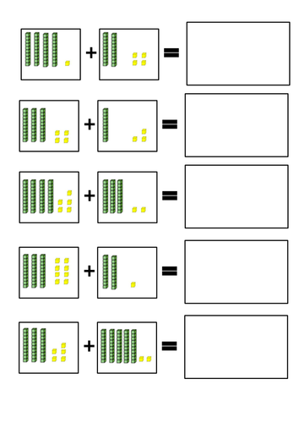

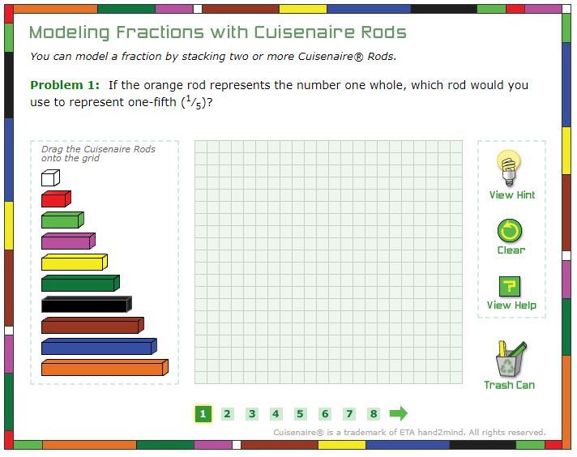

The Mathematics Department believe that by using various teaching approaches backed up by research, using high quality and well-structured resources, excellent teacher instruction and having learners working at a pace that best fits their needs, learners will progress, have the opportunity to excel and will enjoy their experience in a Mathematics classroom.

**Contact us:**If you have any queries regarding your child’s Maths learning or progress please contact the Head of Department – Kirsty Boyd. You can email at [kirsty.boyd@westlothian.org.uk](mailto:kirsty.boyd@westlothian.org.uk) or phone the school on 01506 280180.