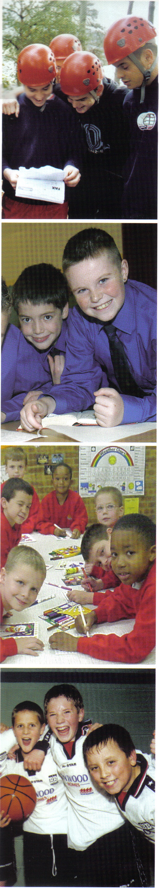
Interested in
joining the adventure?

2nd Linlithgow Boys’ Brigade

For Boys from P2 – S6

Boys can join at any age – not just P2.

Our enrolment night is Thursday 23rd August in Cross House.

Pop in between 6.30pm and 7.30pm-We look forward to seeing you all there.

For more information e-mail
linlithgowBB@outlook.com or find us on facebook

