Halloween Cupcakes

Cup cake Ingredients
- 125g plain flour
- 25g cocoa powder
- 5ml baking powder
- 150g caster sugar
- 50g margarine
- 1 egg
- 8 x 15ml milk

For the cream cheese icing
- 50g cream cheese
- 25g margarine, softened at room temperature
- 150g icing sugar, sifted
- 2.5ml vanilla essence
For the chocolate icing
- 25g icing sugar
- 5ml cocoa powder

Preparation method
- Preheat the oven to 180C/Gas 4. Line a muffin tray with 12 paper cases.
- Add the sugar and margarine and cream. Sift in the flour, cocoa powder and baking powder.
- Whisk in the egg and milk until the mixture is thick and smooth.
- Divide the mixture between the paper case and bake in the oven for 20-25 minutes, or until springy to the touch. Set aside to cool on a cooling rack.
- For the cream cheese icing, beat the cream cheese and butter together in a bowl until well combined. Beat in the icing sugar and vanilla.
- Spoon the icing onto the cupcakes, leaving a small border around the edge.
- For the chocolate icing, sift the icing sugar and cocoa powder into a bowl. Stir in 1 tablespoon of water to form a smooth, thick icing (1 between 2).
- Transfer the mixture to a piping bag with a fine nozzle. (Alternatively, spoon the mixture into the corner of a sandwich bag and snip off the corner, to form a small hole.)
- Carefully pipe 3 concentric circles onto each cupcake. Run a toothpick from the centre to the edge of the cake, through each circle of icing, at 2cm/1in intervals to create a cobweb effect.
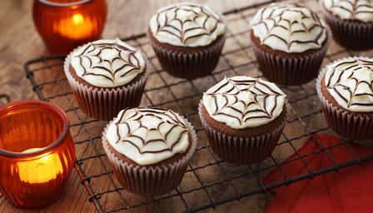
- Set aside for 20 minutes to allow the icing to harden.

