Chicken and Chorizo Paella

Ingredient | 1 Portion | 2 Portions | 4 Portions
Olive oil | 15ml | 15ml | 30ml
Onion | ½ | 1 | 2
Red pepper | ¼ | ½ | 1
red chilli | 1/4 | ½ | 1
clove garlic | 1 | 2 | 4
chicken thigh (skinless and boneless) OR  cooked chicken | -  50g | 2  100g | 4  150g
Chorizo sausage | 20g | 40g | 80g
smoked paprika | 1.25ml | 2.5ml | 5ml
chilli powder | 1.25ml | 2.5ml | 5ml
strand saffron | 1 | 2 | 4
chicken stock | 200ml | 400ml | 800ml
paella rice | 75g | 150g | 300g
peas | 30ml | 60ml | 120ml
chopped tomatoes | 75ml | 150ml | 300ml
Lemon wedge | 1 | 2 | 4

Method:
- Peel and finely dice onion and wash and finely dice pepper and chilli. Crush garlic. Chop chicken into bite sized pieces.
- Heat oil in a frying pan and fry onion, pepper and chilli until soft. Add garlic and gently fry for a further minute.
- Add chicken and chorizo and fry for a further minute.
- Add rice, smoked paprika, chilli powder and saffron and make sure all grains get coated.
- Add stock, bring to the boil, reduce heat and let it simmer for 15-20 minutes. If it dries out, add more water.
- Add peas and tomatoes and cook for a further 10 minutes until rice is completely cooked.
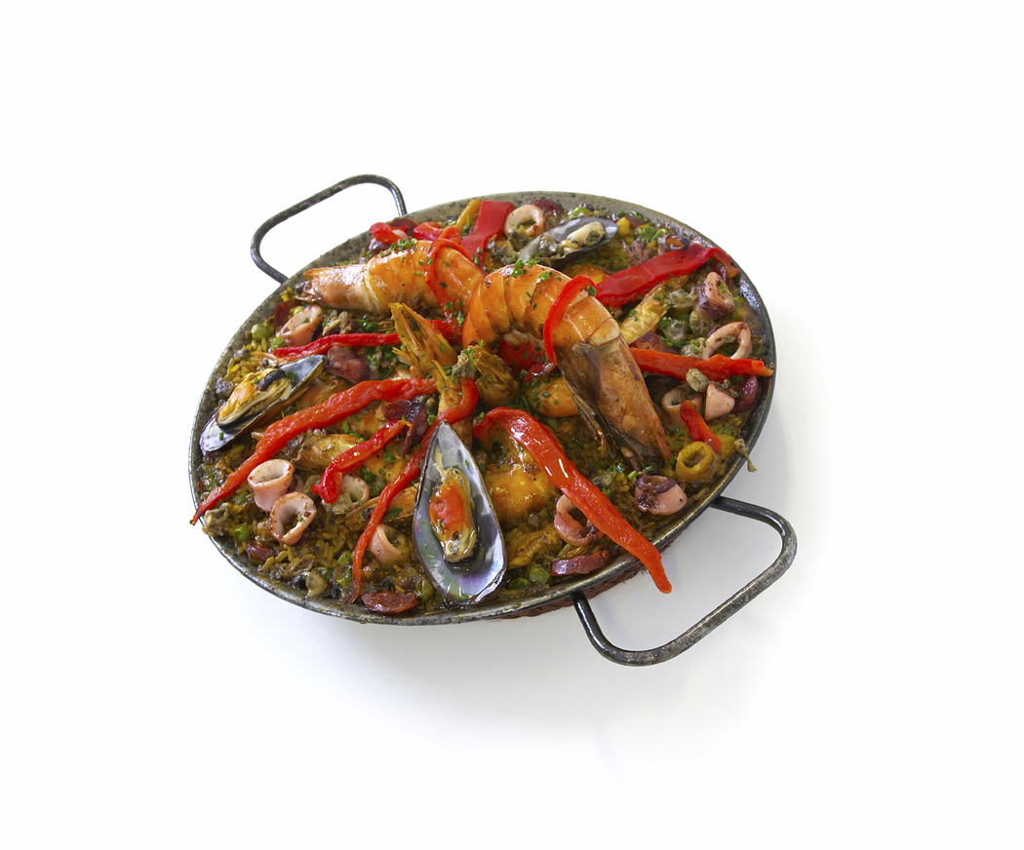
- Serve with wedges of lemon.

